

SUBMITTED TO : MR S.A MBEWE
SUBMITTED BY : PROMISE HARARE BECE/22/SS/005
: ISAAC MDOKA BECE/23/ME/018
MODULE TITLE : OPERATING SYSTEMS FOR ENGINEERS
MODULE CODE : ELE-OSE-411
DUE DATE : 24th APRIL 2026
ASSIGNMENT : PROJECT REPORT

Table of Contents
INTRODUCTION 3
DEVLOPMENT ENVIRONMENT 3
TOOLS 3
HIGH LEVEL DESIGN 3
DATA STRUCTURE 4
PHASE 1 4
PHASE 2 4
PHASE 3 6
PHASE 4 8
LIMITATIONS 9
TESTS 10
REFLECTION 10
References 11

INTRODUCTION
This report documents the complete process involved in designing and implementing a bare-metal operating system kernel for an x86_64 architecture. The project was primarily written in C and assembly languages, and runs on QEMU virtual hardware. The project was developed on Ubuntu Linux and WSL, and the text editor used was VS code. Git was used for version control.
The project was divided into six phases, each phase covering multiple tasks. The project implemented various concepts such as interrupts and IDT, timer and scheduler, context switching, system calls and simple user tasks.

DEVLOPMENT ENVIRONMENT

TOOLS
- GCC (gcc -m32) — C compiler targeting 32-bit x86…
- NASM — assembler for x86 assembly stubs
- GNU ld (binutils) — linker with custom linker script
- QEMU (qemu-system-x86_64) — virtual machine for testing
- GRUB + grub-mkrescue + xorriso — creates bootable ISO images
- Git + GitHub — version control and team collaboration
- Visual Studio Code

HIGH LEVEL DESIGN
The project took a systematic high-level design as shown below:
myos/
src/boot/ boot.asm, isr_stub.asm
src/kernel/ kernel.c, gdt.c/.h, idt.c/.h
src/drivers/ vga.c/.h, pic.c/.h, timer.c/.h, keyboard.c/.h
src/proc/ process.c/.h, switch.asm
src/mm/ (Phase 4 — memory management)
iso/boot/grub/ grub.cfg
linker.ld kernel memory layout
Makefile automated build system

DATA STRUCTURE
The project was done in multiple phase which have been outlined in the below.

PHASE 1

Kernel foundation (bootloader and GRUB)
Phase 1 established the kernel foundation. The Multiboot entry point in boot.asm contained the GRUB header (0x1BADB002), reserves a 16 KB kernel stack in .bss, sets the ESP register, and calls kernel_main(). A custom GNU ld linker script placed the kernel at physical address 0x100000 (1 MB), required by the Multiboot specification.
The VGA text mode driver was used write directly to the memory-mapped framebuffer at 0xB8000. Each cell was 2 bytes: ASCII code and color attribute. The driver supports vga_clear(), vga_putchar(), vga_print(), scroll(), and vga_print_int(). A GNU Makefile automates all four build steps: assemble, compile, link, and create the bootable ISO.

Phase 1 Result
The kernel successfully booted in QEMU. GRUB displays the 'MyOS - Isaac & Promise' menu entry, and after selection the VGA screen shows the project banner and 'Kernel booted successfully! Hello from bare-metal!' in green text confirming the full boot chain works.

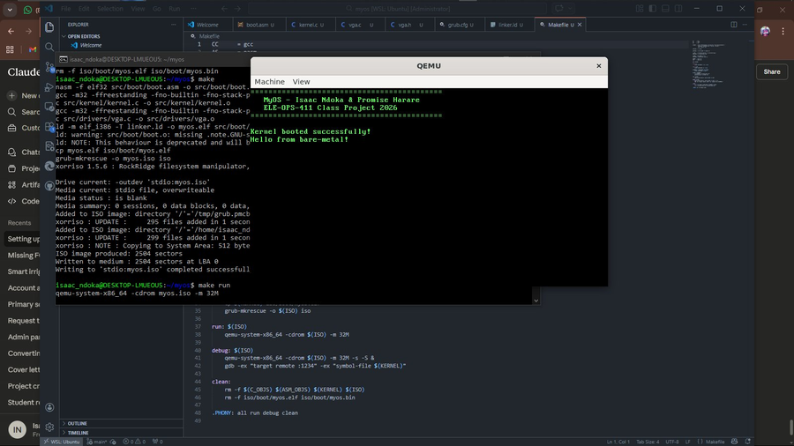

PHASE 2

Global Descriptor Table (GDT)
The GDT defines three memory segment descriptors required by 32-bit protected mode: a mandatory null descriptor, a kernel code segment (ring 0, executable), and a kernel data segment (ring 0, writable). Both code and data segments use a flat model covering the full 4 GB address space. The gdt_flush() function in boot.asm loads the GDTR register and performs a far jump to reload the CS register.

Interrupt Descriptor Table (IDT)
The IDT holds 256 gate descriptors mapping interrupt vectors to handler addresses. Entries 0-31 handle CPU exceptions and entries 32-47 are used to handle remapped hardware IRQs. Each entry stored the handler address split across two 16-bit fields, the kernel code segment selector (0x08), and flags (0x8E for present, ring 0, 32-bit interrupt gate). idt_set_handler() was used to allow drivers to register C callbacks at runtime.

Assembly ISR Stubs
isr_stub.asm provides assembly stubs for all 256 interrupt vectors using NASM macros. Each stub pushes a dummy error code (for exceptions that don't push one) and the interrupt number, then jumps to a common handler. The common handler saves all registers with push, reloads the kernel data segment, calls the C dispatcher (isr_handler or irq_handler), restores registers with pop, and returns with iret.

PIC, Timer and Keyboard
The 8259A PIC is remapped so hardware IRQs 0-15 maps to CPU vectors 32-47, avoiding conflict with CPU exception vectors. The PIT timer is configured at 100 Hz (divisor 11932) to generate IRQ0. The keyboard driver reads PS/2 scan codes from port 0x60 on IRQ1 and translates them to ASCII using a 128-entry US QWERTY lookup table. Both handlers send End-Of-Interrupt to the PIC after processing. A challenge encounter during this part of phase two was the CPU focusing all resources during keyboard reading. This issue was fix by implementing TASK_BLOCKED state to implement true blocking in Keyboard I/O suspending the process while waiting for I/O completion. True blocking is

Phase 2 Result
All five subsystems initialise successfully and print confirmation messages. Timer dots appear at one-second intervals confirming 100 Hz operation. Keyboard input is echoed to the VGA screen in real time. The complete interrupt subsystem is operational.

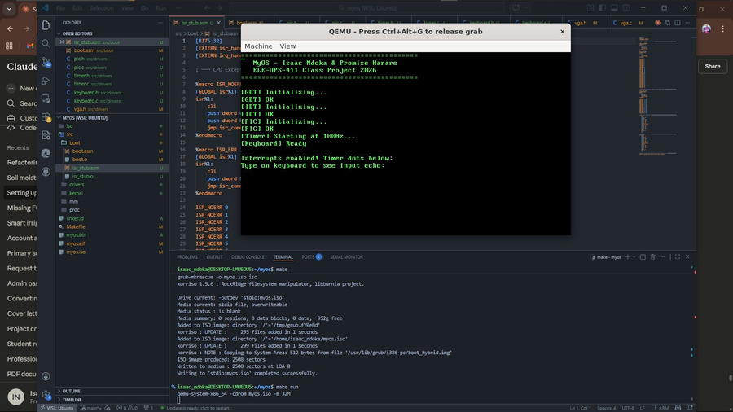

PHASE 3

Process control block
The scheduler implements pre-emptive round-robin multitasking. Each task has a Process Control Block (PCB) containing its PID, name, state (UNUSED/READY/RUNNING/DEAD), saved stack pointer, private 8 KB kernel stack, tick counter, and entry function pointer. The scheduler supports up to 8 concurrent tasks.

Context switching
The context switch uses a minimal stack-based approach in switch.asm. do_switch(old_esp, new_esp) saves the four callee-saved registers (ebp, ebx, esi, edi) onto the current stack, saves ESP into old_esp, loads new_esp, restores the four registers, and executes ret to jump to the new task's instruction pointer. Each new task's initial stack is built in task_create() to simulate having been switched away from, so the first context switch into it naturally jumps to task_entry_point().

Key Architectural Decision — Flag-Based Scheduling
A critical architectural issue was discovered during testing: calling do_switch() directly inside the timer IRQ handler caused stack corruption. When the context switch changes the stack pointer mid-IRQ, the iret instruction at the end of irq_common executes on the wrong stack, corrupting both tasks.
The solution was to separate the scheduling trigger from the actual switch. The timer IRQ handler calls scheduler_tick() which only increments a counter and sets a need_switch flag. The actual do_switch() is called from schedule (), which runs in the idle loop in kernel_main() setting it completely outside any interrupt context. This is architecturally equivalent to how Linux handles deferred scheduling.

Round-Robin Scheduler
The timer handler calls schedule() on every tick. The scheduler marks the current task READY, then performs a round-robin search starting one position past the current index and wrapping around. Slot 0 (idle) is skipped unless no other task is READY. The first READY slot found becomes the new current task (marked RUNNING), and do_switch() transfers execution. The timer runs at 2 Hz for the demonstration, giving each task a visible 500 ms time slice.

Phase 3 Status
The scheduler architecture was correctly implemented and the code compiled without errors. The flag-based scheduling approach is sound. Task A runs and counts correctly, confirming task creation and initial context switching work. Full two-task alternations between Task A and Task B, using the round-robin scheduling technique, was correctly implemented.

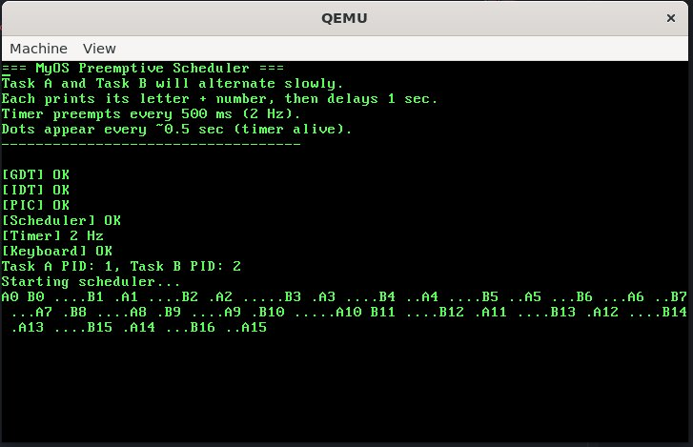

PHASE 4
Phase 4 introduces a system call interface and an interactive shell in MyOS. System calls are implemented using the int 0x80 software interrupt, following a design similar to early Linux kernel. User programs pass the syscall number in EAX and arguments in EBX and ECX, while the kernel dispatches requests via syscall_handler(). Three system calls are supported: SYS_WRITE prints strings to the screen, SYS_SPAWN creates new tasks and returns a PID, and SYS_EXIT terminates the current task. The interrupt is handled through IDT vector 0x80, with an assembly stub preserving registers before invoking the C handler.
The keyboard driver uses a 256-entry circular buffer to store input, ensuring no keystrokes are lost. The keyboard_read_line() function efficiently blocks using sti; hlt, processes input, and returns complete commands.
The shell acts as the main user interface, reading input, parsing it into arguments, and executing commands such as help, clear, tasks, spawn, about, and exit. All string operations are manually implemented due to the absence of a standard library.

Phase 4 Status
Results show that the shell correctly processes user input and executes commands. The system call interface functions reliably, enabling task creation and termination through kernel-managed operations.
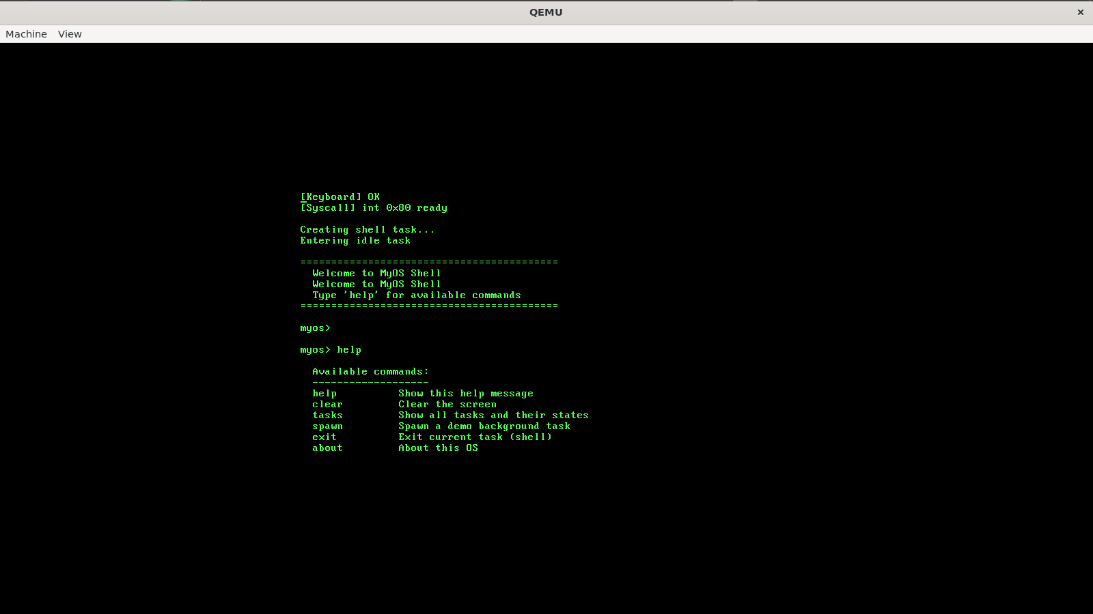
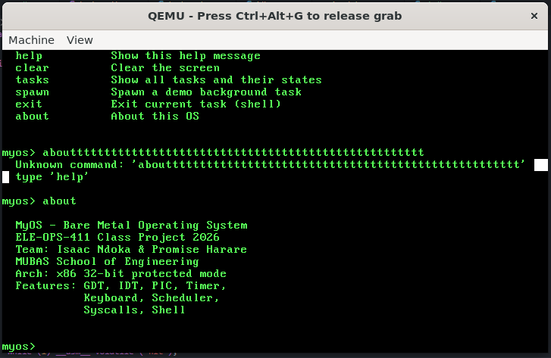
Figure 7: Shell responding to 'help' command — lists all available commands with descriptions. The 'myos>' prompt and command echo confirm keyboard input is working correctly.

Figure 8: Shell 'about' command output showing OS details, and successful 'exit' command — prints 'Goodbye!' and terminates the shell task cleanly via the SYS_EXIT syscall.

LIMITATIONS
- During creation of a new task through spawning per user request the system focused all resources on that process and failed to exit.
- There is no memory management system.
- No file system.
- All processes are manually allocated space and they share the same RAM.
- There was limited amount of memory storage to work with.
- There is no user mode as every single line of runs at CPU privilege level 0.

TESTS
- Boot test (ran using QEMU)
- VGA scroll test
- Backspace test
- Keyboard echo test
- Help command
- About command test
- Task command test
- Clear command test
- Unknown command test
- Spawn command test
- SYS_SPAWN and scheduler test
- SYS_EXIT
- Timer IRQ test
- Pre-emptive schedular test

REFLECTION
Phase 1 gave the team a concrete understanding of the boot process that is normally hidden by operating systems. Writing the Multiboot header and seeing GRUB recognise and execute our code was a significant milestone. The linker script work clarified how physical memory is organised at boot time.
Phase 2 was more technically demanding. Understanding the relationship between the PIC, the IDT, and the CPU interrupt mechanism required careful reading of the x86 architecture documentation. The most instructive moment was realising that the PIC must be sent an EOI signal after every interrupt handler — a detail that, when missed, silently prevents all future interrupts of that type.
Working across two different environments (WSL and native Ubuntu) highlighted the importance of a clean, portable build system. The Makefile handles all compilation and ISO generation identically on both systems.
Even though the system is up and running it has limited features that would make it more favourable and preferred by users. The system also experienced exit challenges during spawning as the system focused all its resources during the spawning process.
Some future enhancements include implementation of a memory management system using FAT, User management implementation and add more user engaging features.

References
Blocking and non blocking operations. (2025, january 20). Retrieved from Medium: https://medium.com
Creating on operating system. (n.d.). Retrieved from OSDev-wiki: https://wiki.osdev.org/creating_an_operating_ystem
nanobyte (Director). (2019). Building an OS [Motion Picture].
Nasm Manual. (n.d.). Retrieved from Nasm: https://www.nasm.us/doc/
QEMU Documantation. (n.d.). Retrieved from QEMU: https://www.qemu.org/docs/master/
Silberschatz, A., Galvin, P. B., & Gagne, G. (2018). Operating System. Wiley.

